School Holiday List 2023/24
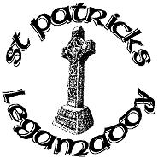
New academic year commences Tuesday 29th August
(all dates are inclusive)
Term 1
27th October- 3rd November Halloween Holidays
22nd December – 2nd January Christmas Holidays
Term 2
9th-16th February Mid Term Break
18th March St Patrick’s Day
28th March -5th April Easter Holidays
Term 3
6th May May Bank Holiday
27th May – 31st May Mid-term break
½ day 28th June Summer Holidays

These holidays are in accordance with those harmonised by CCMS, EA Transport and School Meals. We will make every effort to attempt to keep to these days and parents will be notified in good time if any changes are necessary.

