Holiday List 2018/19

**School Opens**

Tuesday 27th August[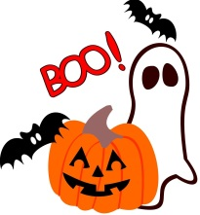](http://www.google.co.uk/url?sa=i&rct=j&q=&esrc=s&source=images&cd=&cad=rja&uact=8&ved=&url=http://www.clipartpanda.com/categories/halloween-clipart&psig=AFQjCNE5ZAUnXNbnlJdpODr0opsRE8INZQ&ust=1495010330953311)

Mid-Term Break (Halloween)

Fri 26th October – Friday 2nd November[](http://www.google.co.uk/url?sa=i&rct=j&q=&esrc=s&source=images&cd=&cad=rja&uact=8&ved=0ahUKEwik_rz_gfTTAhXMFsAKHTl0A5YQjRwIBw&url=http://www.mycutegraphics.com/graphics/christmas-graphics.html&psig=AFQjCNFfWin-rbMJE2x_-gbSSYJqFsTSyQ&ust=1495010381265167)

Christmas Holidays

Monday 24th December – Friday 4th January

Mid-Term Break

Monday 18th February – Friday 22nd February

St Patrick's Day

Monday 18th March[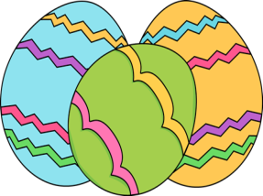](http://www.google.co.uk/url?sa=i&rct=j&q=&esrc=s&source=images&cd=&cad=rja&uact=8&ved=0ahUKEwih6_eTgvTTAhUlC8AKHQKbBBcQjRwIBw&url=http://www.mycutegraphics.com/graphics/easter-egg-images.html&psig=AFQjCNHKTYfHYkx7a_xokHuOpT9OOIEtUQ&ust=1495010470185990)

Easter Holidays

Friday 19th April – Friday 26th April

May Bank Holiday

Monday 6th May  
Mid-Term Break

Monday 27th May – Friday 31st May

These holidays are in accordance with those harmonised by CCMS, EA Transport and School Meals. We will make every effort to attempt to keep to these days and parents will be notified in good time if any changes are necessary.