Monday – Acti-Sport
2-3pm P1-P3 (10 weeks - £30)
3-4pm P4-P7
Tuesday – Bricks4Kids
Bricks 4 Kidz is designed to teach the principles of Science, Technology, Engineering and Maths (STEM), to children. The program provide an extraordinary atmosphere for students to build unique creations, play games, and have loads of fun using LEGO® bricks. The activities are designed to trigger young children’s lively imaginations and build their self-confidence.
2-3pm P1-3 (10 weeks - £50)
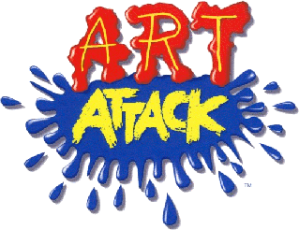
3-4pm P4-7
Wednesday – ART ATTACK
2-3pm P1-P3 (10 weeks - £30)
3-4pm P4-P7
Thursday – Mindfulness
2-2-3pm P1-P3 (9 weeks - £27)
3-4pm P4-P7
Registration for clubs will take place on Thursday 10th January from 8.30am. Clubs will commence on week beginning Monday 15th January.

